**DBMS-Driven Financial and Investment Management System**

**Codes Used**

1. **Database creation sql code**

-- Create Customer Table

CREATE TABLE Customer (

Cust_ID INT AUTO_INCREMENT PRIMARY KEY,

F_Name VARCHAR(50),

L_Name VARCHAR(50),

DOB DATE,

Age INT,

Address TEXT,

Mobile_no VARCHAR(15)

);

-- Create Bank Table

CREATE TABLE Bank (

B_name VARCHAR(50),

Code INT PRIMARY KEY,

City VARCHAR(50),

Address TEXT

);

-- Create Branch Table

CREATE TABLE Branch (

Branch_Code INT PRIMARY KEY,

Branch_name VARCHAR(50),

Address TEXT,

Code INT,

FOREIGN KEY (Code) REFERENCES Bank(Code)

);

-- Create Employee Table

CREATE TABLE Employee (

Emp_id INT AUTO_INCREMENT PRIMARY KEY,

Emp_name VARCHAR(100),

Address TEXT,

Mobile_no VARCHAR(15),

Branch_Code INT,

FOREIGN KEY (Branch_Code) REFERENCES Branch(Branch_Code)

);

-- Create Account Table

CREATE TABLE Account (

Account_No INT AUTO_INCREMENT PRIMARY KEY,

Balance DECIMAL(10, 2),

Cust_ID INT,

FOREIGN KEY (Cust_ID) REFERENCES Customer(Cust_ID)

);

-- Create Investments Table

CREATE TABLE Investments (

Investment_ID INT AUTO_INCREMENT PRIMARY KEY,

AccountID INT,

Amount DECIMAL(10, 2),

LockInPeriod INT,

Interest_rate DECIMAL(5, 2),

Inception_date DATE,

FOREIGN KEY (AccountID) REFERENCES Account(Account_No)

);

-- Create Returns Table

CREATE TABLE Returns (

Return_ID INT AUTO_INCREMENT PRIMARY KEY,

Return_amt DECIMAL(10, 2),

Return_Date DATE,

Investment_ID INT,

FOREIGN KEY (Investment_ID) REFERENCES Investments(Investment_ID)

);

-- Create Policy Table

CREATE TABLE Policy (

Policy_ID INT AUTO_INCREMENT PRIMARY KEY,

Policy_Name VARCHAR(100),

Duration INT, -- Duration in months

Interest_Rate DECIMAL(5, 2)

);

INSERT INTO Policy (Policy_Name, Duration, Interest_Rate)

VALUES

('Fixed Deposit', 12, 6.5),

('Recurring Deposit', 24, 5.8),

('Mutual Funds', 36, 8.2);

1. **App.py code**

from flask import Flask, render_template, request, redirect

import mysql.connector

app = Flask(__name__)

# Database connection

db = mysql.connector.connect(

host="localhost",

user="root", # Default XAMPP MySQL user

password="", # No password for XAMPP MySQL

database="InvestmentManagement"

)

@app.route('/')

def index():

return render_template('index.html')

@app.route('/add_customer', methods=['GET', 'POST'])

def add_customer():

if request.method == 'POST':

fname = request.form['fname']

lname = request.form['lname']

dob = request.form['dob']

age = request.form['age']

address = request.form['address']

mobile_no = request.form['mobile_no']

cursor = db.cursor()

cursor.execute("""

INSERT INTO Customer (F_Name, L_Name, DOB, Age, Address, Mobile_no)

VALUES (%s, %s, %s, %s, %s, %s)

""", (fname, lname, dob, age, address, mobile_no))

db.commit()

return redirect('/')

return render_template('add_customer.html')

@app.route("/investment_policies", methods=["GET", "POST"])

def investment_policies():

policies = [

{"Policy_ID": 1, "Policy_Name": "Fixed Deposit", "Duration": 12, "Interest_Rate": 6.5},

{"Policy_ID": 2, "Policy_Name": "Recurring Deposit", "Duration": 24, "Interest_Rate": 5.8},

{"Policy_ID": 3, "Policy_Name": "Mutual Funds", "Duration": 36, "Interest_Rate": 8.2},

]

if request.method == "POST":

# Handle investment form submission

if 'amount' in request.form: # Investment form

account_id = request.form['account_id']

policy_id = request.form['policy_id']

amount = float(request.form['amount'])

investment_success = "Investment Successful"

return render_template("investment_policies.html", investment_success=investment_success, policies=policies)

# Handle return calculation form submission

elif 'customer_id' in request.form: # Return calculation form

customer_id = request.form['customer_id']

policy_id = request.form['policy_id']

principal = float(request.form['principal'])

interest_rate = 6.5 # Example rate

lock_in_period = 12 # Example period

return_amount = principal * (1 + (interest_rate / 100) * lock_in_period)

monthly_payment = return_amount / lock_in_period

return_data = {

"policy": policy_id,

"principal": principal,

"return_amount": return_amount,

"monthly_payment": monthly_payment,

"lock_in_period": lock_in_period

}

return render_template("investment_policies.html", return_data=return_data, policies=policies)

return render_template("investment_policies.html", policies=policies)

@app.route('/calculate_return', methods=['GET', 'POST'])

def calculate_return():

return_data = None

if request.method == 'POST':

customer_id = request.form['customer_id']

policy_id = request.form['policy_id']

principal = float(request.form['principal'])

cursor = db.cursor(dictionary=True)

cursor.execute("SELECT * FROM Policy WHERE Policy_ID = %s", (policy_id,))

policy = cursor.fetchone()

if policy:

lock_in_period = policy['Duration']

interest_rate = policy['Interest_Rate']

return_amount = principal * (1 + (float(interest_rate) / 100) * lock_in_period)

monthly_payment = return_amount / lock_in_period # Monthly payment estimate

return_data = {

'policy': policy['Policy_Name'],

'principal': principal,

'return_amount': return_amount,

'monthly_payment': monthly_payment,

'lock_in_period': lock_in_period

}

return render_template('calculate_return.html', return_data=return_data)

@app.route('/view_customer', methods=['GET', 'POST'])

def view_customer():

customer_data = None

if request.method == 'POST':

customer_id = request.form['customer_id']

cursor = db.cursor(dictionary=True)

cursor.execute("""

SELECT Cust_ID, F_Name, L_Name, Mobile_no FROM Customer WHERE Cust_ID = %s

""", (customer_id,))

customer = cursor.fetchone()

cursor.execute("""

SELECT Account_No, Balance FROM Account WHERE Cust_Id = %s

""", (customer_id,))

accounts = cursor.fetchall()

cursor.execute("""

SELECT Investment_ID, Amount, Policy_Name, LockInPeriod, Interest_rate

FROM Investments WHERE AccountID IN (SELECT Account_No FROM Account WHERE Cust_Id = %s)

""", (customer_id,))

investments = cursor.fetchall()

cursor.execute("""

SELECT r.Return_amt, r.Investment_ID FROM Returns r

INNER JOIN Investments i ON r.Investment_ID = i.Investment_ID

INNER JOIN Account a ON i.AccountID = a.Account_No

WHERE a.Cust_Id = %s

""", (customer_id,))

returns = cursor.fetchall()

customer_data = {

'customer': customer,

'accounts': accounts,

'investments': investments,

'returns': returns

}

return render_template('view_customer.html', customer_data=customer_data)

if __name__ == '__main__':

app.run(debug=True)

1. **Index.html**

<!DOCTYPE html>

<html>

<head>

<title>Investment Management</title>

</head>

<body>

<h1>Investment Management System</h1>

<a href="/add_customer">Add Customer</a><br>

<a href="/investment_policies">Investment Policies</a><br>

<a href="/view_customer">View Customer</a>

</body>

</html>

1. **Add_customer.html**

<!DOCTYPE html>

<html>

<head>

<title>Add Customer</title>

</head>

<body>

<h1>Add Customer</h1>

<form method="POST">

<label>First Name:</label><br>

<input type="text" name="fname" required><br>

<label>Last Name:</label><br>

<input type="text" name="lname" required><br>

<label>Date of Birth:</label><br>

<input type="date" name="dob" required><br>

<label>Age:</label><br>

<input type="number" name="age" required><br>

<label>Address:</label><br>

<textarea name="address" required></textarea><br>

<label>Mobile Number:</label><br>

<input type="text" name="mobile_no" required><br>

<input type="submit" value="Add Customer">

</form>

</body>

</html>

1. **Investment_policies.html**

<!DOCTYPE html>

<html>

<head>

<title>Investment Policies</title>

</head>

<body>

<h1>Investment Policies</h1>

<table border="1">

<tr>

<th>ID</th>

<th>Policy Name</th>

<th>Duration (months)</th>

<th>Interest Rate</th>

</tr>

{% for policy in policies %}

<tr>

<td>{{ policy.Policy_ID }}</td>

<td>{{ policy.Policy_Name }}</td>

<td>{{ policy.Duration }}</td>

<td>{{ policy.Interest_Rate }}%</td>

</tr>

{% endfor %}

</table>

<h2>Make an Investment</h2>

{% if investment_success %}

<p>{{ investment_success }}</p>

{% endif %}

<form method="POST" action="/investment_policies">

<label>Account ID:</label>

<input type="number" name="account_id" required><br><br>

<label>Select Policy:</label>

<select name="policy_id" required>

{% for policy in policies %}

<option value="{{ policy.Policy_ID }}">{{ policy.Policy_Name }}</option>

{% endfor %}

</select><br><br>

<label>Investment Amount:</label>

<input type="number" name="amount" step="0.01" required><br><br>

<input type="submit" value="Invest">

</form>

<h2>Calculate Return</h2>

<form method="POST" action="/investment_policies"> <!-- Make sure this action is correct -->

<label>Customer ID:</label>

<input type="number" name="customer_id" required><br><br>

<label>Select Policy:</label>

<select name="policy_id" required>

{% for policy in policies %}

<option value="{{ policy.Policy_ID }}">{{ policy.Policy_Name }}</option>

{% endfor %}

</select><br><br>

<label>Principal Amount:</label>

<input type="number" name="principal" step="0.01" required><br><br>

<input type="submit" value="Calculate">

</form>

{% if return_data %}

<h3>Return Estimate</h3>

<p>Policy: {{ return_data.policy }}</p>

<p>Principal: {{ return_data.principal }}</p>

<p>Estimated Return Amount: {{ return_data.return_amount }}</p>

<p>Monthly Payment: {{ return_data.monthly_payment }}</p>

<p>Lock-in Period: {{ return_data.lock_in_period }} months</p>

{% endif %}

<a href="/">Back to Home</a>

</body>

</html>

1. **Calculate_return.html**

<!DOCTYPE html>

<html lang="en">

<head>

<meta charset="UTF-8">

<meta name="viewport" content="width=device-width, initial-scale=1.0">

<title>Calculate Return</title>

</head>

<body>

<h1>Calculate Investment Return</h1>

<!-- Form to calculate the return based on policy and principal amount -->

<form method="POST">

<label for="policy_id">Select Policy:</label>

<select name="policy_id" id="policy_id" required>

{% for policy in policies %}

<option value="{{ policy.Policy_ID }}">{{ policy.Policy_Name }} (Duration: {{ policy.Duration }} months, Interest: {{ policy.Interest_Rate }}%)</option>

{% endfor %}

</select><br><br>

<label for="principal">Principal Amount:</label>

<input type="number" id="principal" name="principal" step="0.01" required><br><br>

<input type="submit" value="Calculate Return">

</form>

<!-- If return amount is calculated, display it -->

{% if return_amount %}

<h3>Estimated Return</h3>

<p><strong>Policy Name:</strong> {{ policy_name }}</p>

<p><strong>Principal Amount:</strong> {{ principal }}</p>

<p><strong>Estimated Return Amount:</strong> {{ return_amount }}</p>

<p><strong>Estimated Monthly Payment:</strong> {{ monthly_payment }}</p>

<p><strong>Lock-in Period:</strong> {{ lock_in_period }} months</p>

{% endif %}

<br><br>

<a href="/">Back to Home</a>

</body>

</html>

1. **View_customer.html**

<!DOCTYPE html>

<html>

<head>

<title>View Customer</title>

</head>

<body>

<h1>View Customer</h1>

<form method="POST">

<label>Customer ID:</label>

<input type="text" name="customer_id" required>

<input type="submit" value="Search">

</form>

{% if customer_data %}

<h2>Customer Details</h2>

<p>Name: {{ customer_data.customer.F_Name }} {{ customer_data.customer.L_Name }}</p>

<p>Mobile: {{ customer_data.customer.Mobile_no }}</p>

<h2>Accounts</h2>

<table border="1">

<tr>

<th>Account No</th>

<th>Balance</th>

</tr>

{% for account in customer_data.accounts %}

<tr>

<td>{{ account.Account_No }}</td>

<td>{{ account.Balance }}</td>

</tr>

{% endfor %}

</table>

<h2>Investments</h2>

<table border="1">

<tr>

<th>Investment ID</th>

<th>Amount</th>

<th>Policy Name</th>

<th>Lock-in Period</th>

<th>Interest Rate</th>

</tr>

{% for investment in customer_data.investments %}

<tr>

<td>{{ investment.Investment_ID }}</td>

<td>{{ investment.Amount }}</td>

<td>{{ investment.Policy_Name }}</td>

<td>{{ investment.LockInPeriod }}</td>

<td>{{ investment.Interest_rate }}</td>

</tr>

{% endfor %}

</table>

<h2>Returns</h2>

<table border="1">

<tr>

<th>Return Amount</th>

<th>Investment ID</th>

</tr>

{% for ret in customer_data.returns %}

<tr>

<td>{{ ret.Return_amt }}</td>

<td>{{ ret.Investment_ID }}</td>

</tr>

{% endfor %}

</table>

{% endif %}

</body>

</html>

**Implementation Snippets**

**Xampp tool**

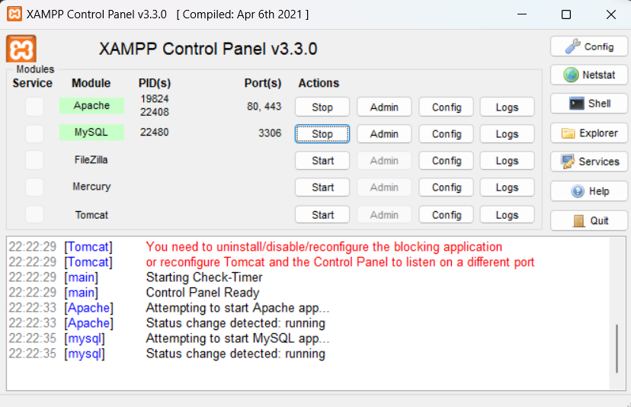

**Initial state of our database**

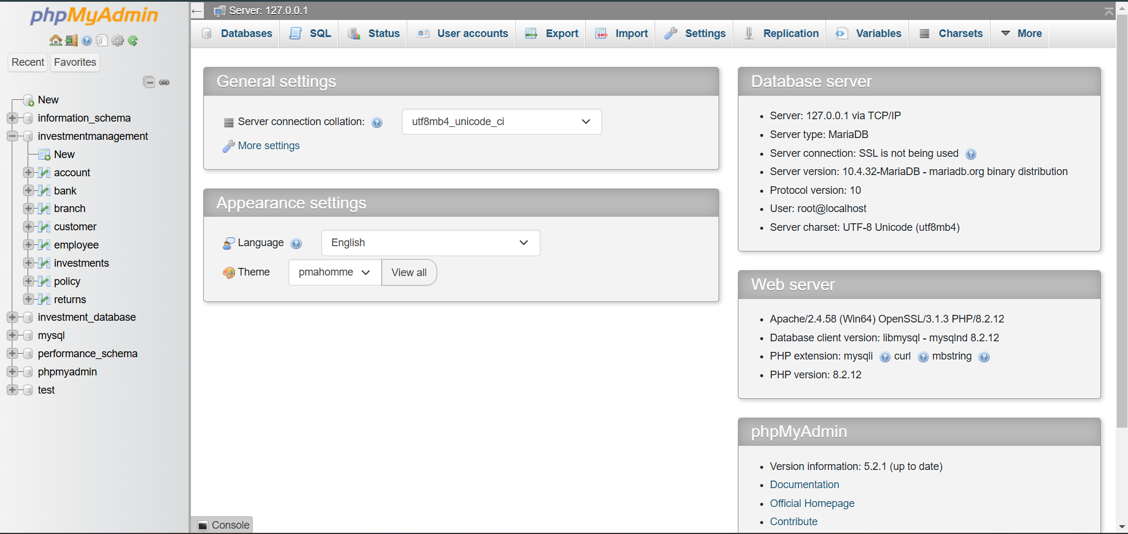

**Project front end**

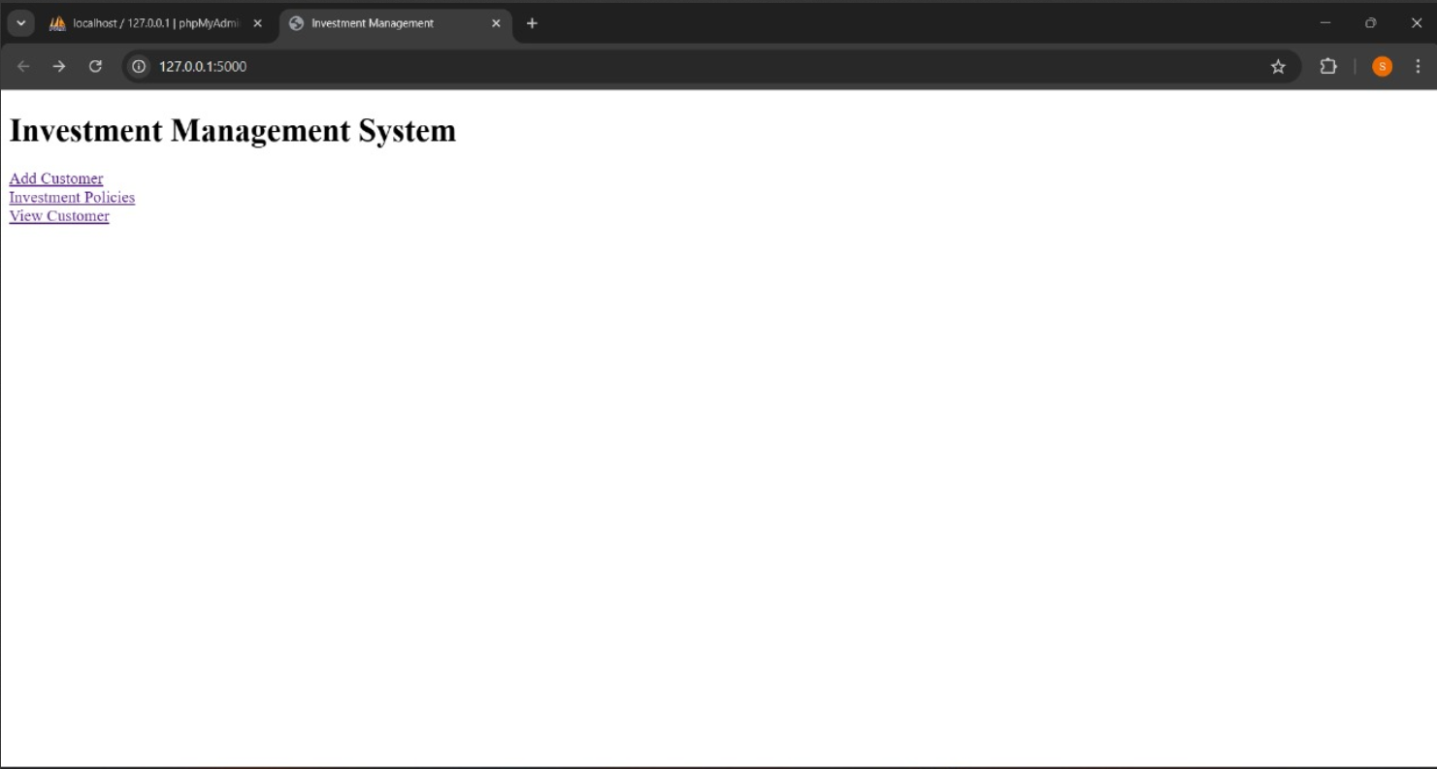

1. **Adding a new customer**

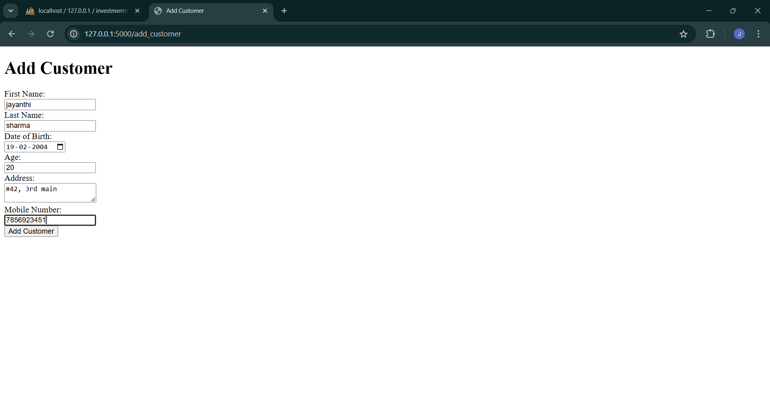

**Updates in database**

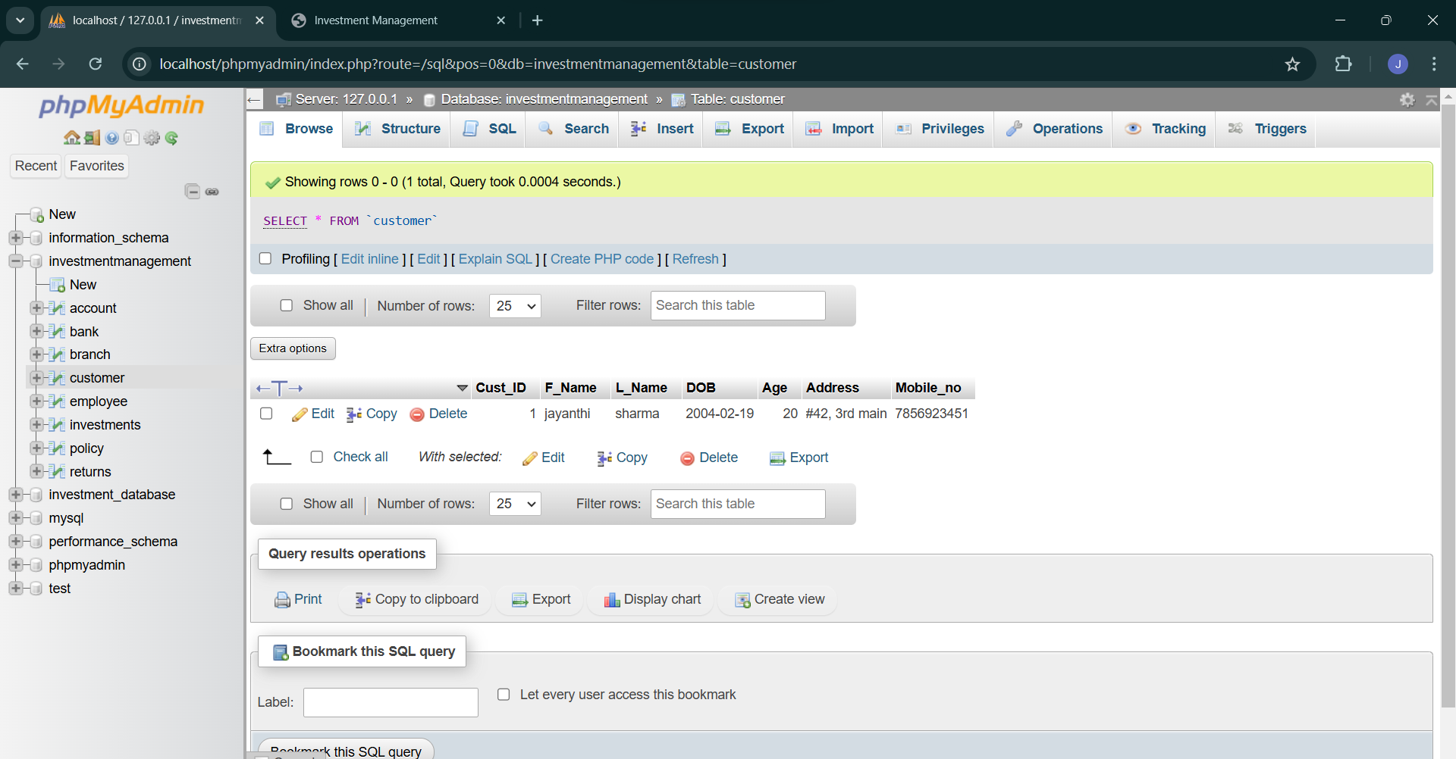

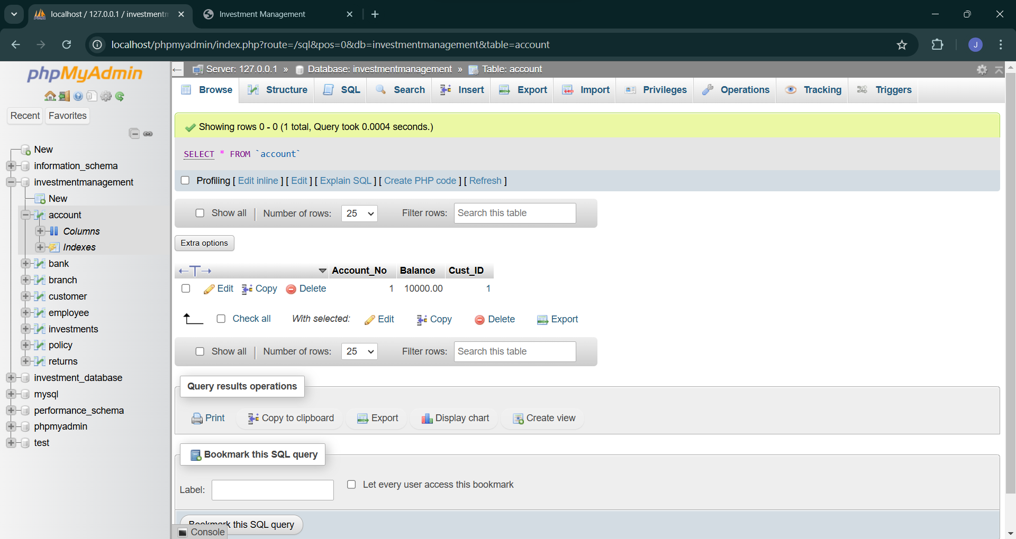

1. **Calculating returns for an fd**

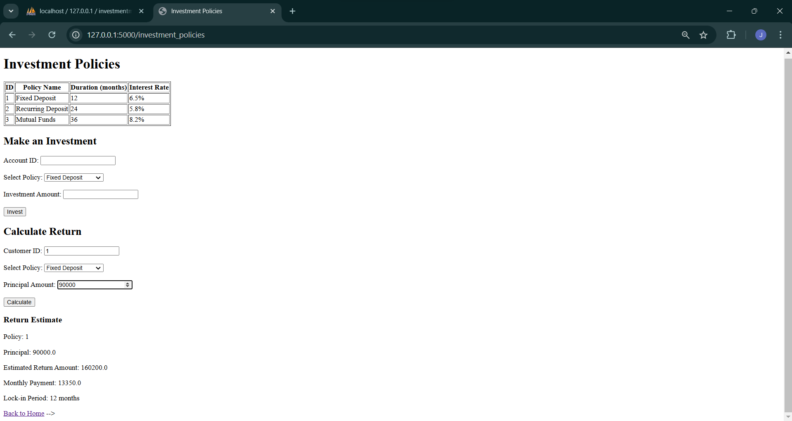

1. **Making an investment**

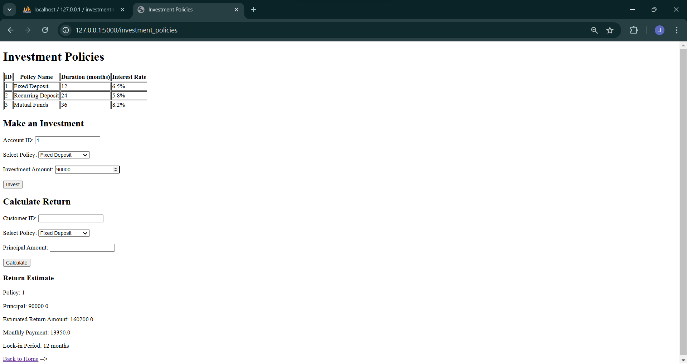

**Database updates**

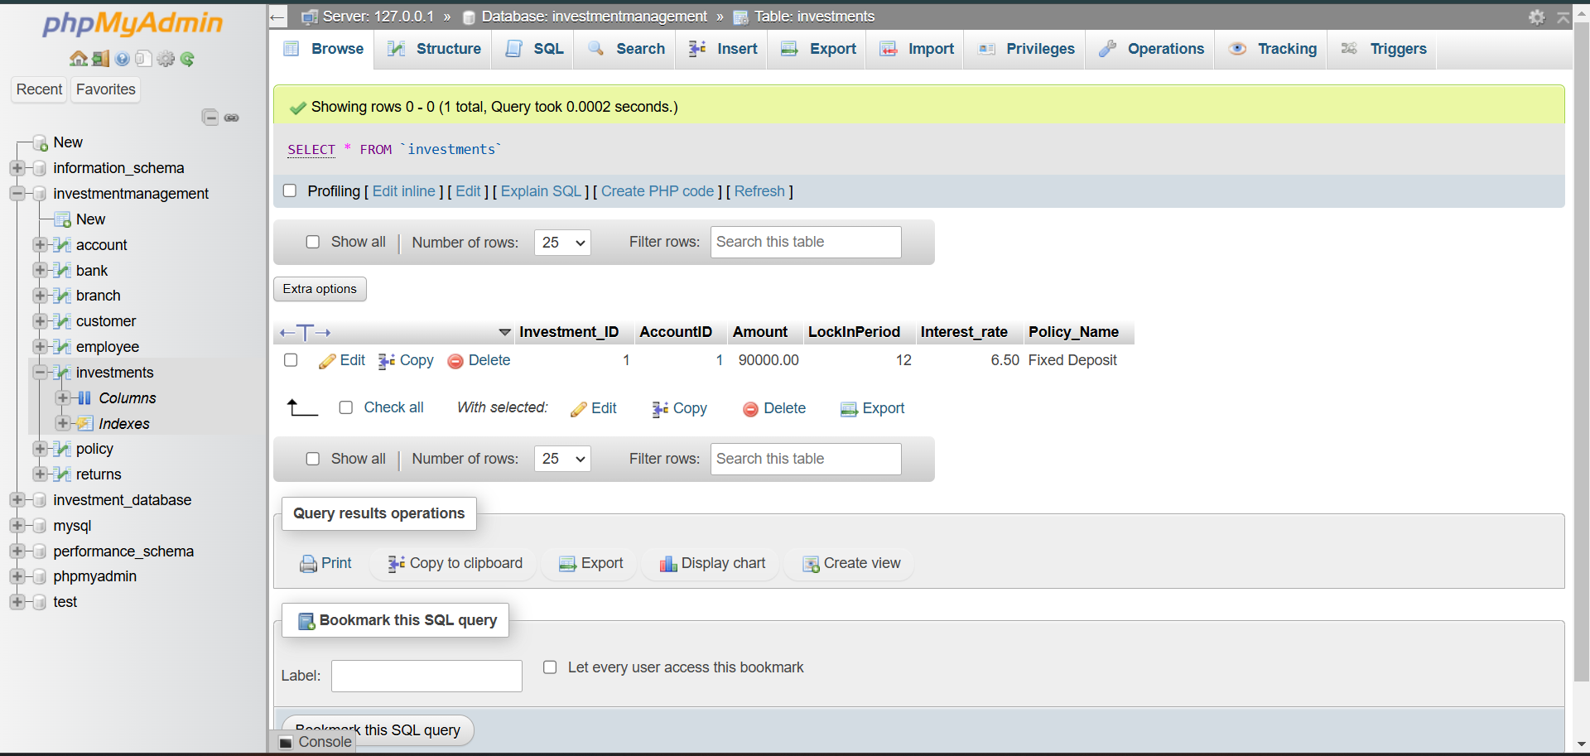

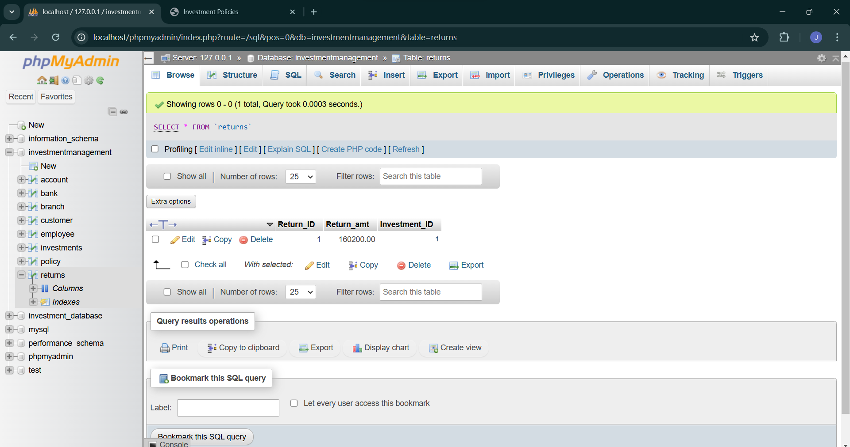

1. **Viewing a customer**

